ONTOLOGICAL SEMANTIC SEARCH ENGINE

Details:
- Name : Varun Joshi
Department : Information Science
College : BVBCET
Email ID : varunthegeek@gmail.com
Ph. Num : 916447856

- Name : Shreya Kampli
Department : Information Science
College : BVBCET
Email ID : shreyakampli@gmail.com
Ph. Num : 9738110234

ONTOLOGICAL SEMANTIC SEARCH ENGINE
A Better Search

Varun Joshi
Dept of Information Science
BVBCET
Hubli, India
varunthegeek@gmail.com
Shreya Kampli
Dept of Information Science
BVBCET
Hubli, India
shreyakampli@gmail.com

Abstract— It is commonly observed that people try to have ease and save their work and time also.
The search engines which are most commonly used presently are based on keyword search and sometimes have irrelevant search results. The semantic search engine provides comprehensive means to produce precise answers that on one hand satisfy user queries and on the other hand are self explanatory. Semantic technologies promise to produce precise answers to the user queries by taking the advantage of availability of explicit semantics of information in a context of semantic web. Ontology is a systematic arrangement of all of the important categories of objects or concepts which exist in some field of discourse, showing the relations between them.
The paper provides a framework and implementation details to semantically relate the keywords provided by the user of the system and searching the data in internet based on their semantic relevance and extracting the related search data from the links having different types of file formats and storing them in a single web page using the ontological method.
Keywords-semantic web,ontology,RDF,DOM

Introduction
The Semantic Web is the representation of data on the World Wide Web. It is based on the Resource Description Framework (RDF), which integrates a variety of applications using XML for syntax and URIs for naming. – W3C Semantic Web. This paper uses RDF encoded Semantic Web documents which are searched in response to a user query for exact results.
Search Engine is the most important tool to discover any information in World Wide Web. In a row with the traffic growth of web, traditional search engine nowadays is not appropriate anymore to be used so hence we move on to semantic search engines. Semantic technologies promise a next generation of search engines which promise to produce precise answers to the user queries by taking the advantage of availability of explicit semantics of information in a context of semantic web.

TECHNOLOGies USED

ONTOLOGY
Ontology is an explicit specification of some topic. For our purposes, it is a formal and declarative representation which includes the vocabulary (or names) for referring to the terms in that subject area and the logical statements that describe what the terms are, how they are related to each other, and how they can or cannot be related to each other. Therefore, Ontology provides a vocabulary for representing and communicating knowledge about some topic and a set of relationships that hold among the terms in that vocabulary.

Resource Description Framework(RDF)
RDF is the standard for encoding metadata and other knowledge on the Semantic Web. RDF is an abstract model, a way to break down knowledge into discrete pieces, and can be stored in a variety of formats. RDF is a standard model for data interchange on the Web.
The foundation of RDF is a model for representing named properties and property value. The basic data model consists of three object types: Resources, Properties, Statement
1. Resources: All thing being described by RDF expressions are called.
2. Properties: A property is a specific aspect, characteristics, attribute or relation used to describe a resource.
3. Statement: A specific resource together with a named property plus the value of that property for that resources an RDF statement.
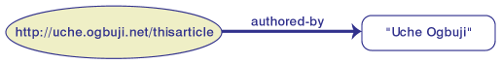
For example: article is authored by Uche Ogbuji. A subject ("this article"), a predicate ("is authored by"), and an object ("Uche Ogbuji").

TRIPLE PARSING
Parsing is the act of splitting up query into its component.
‘Mary feeds Spot’ parses as
Subject=Mary, proper noun
Predicate=feeds, present tense
Object=Spot, proper noun

WORDNET LIBRARY
From within the application you started you can use WordNet Searching by first obtaining an instance of WordNetDatabase with code like the following, which assumes that you’ve performed an import of the classes in the edu.smu.tspell.wordnet package: WordNetDatabase database=WordNetDatabase.getFileInstance ();
Once you’ve done so, you can begin to retrieve synsets from the database as shown in the example below. This code retrieves all noun synsets for “fly” and loops through each one printing its word form, its description, and the number of hyponyms associated with that noun synset.

ACRONYMS AND ABBREVATIONS
- RDF: Resource Description Framework
- XML: Extensible Markup Language
- JSP: Java Server Pages
- GUI: Graphical User interface
- DOM: Document Object Model
- URI: Uniform Resource Identifier
- W3C : World Wide Web (W3) Consortium
- URL : Uniform Resource Locator
- NLP: Natural Language Processing.

SYSTEM MODEL

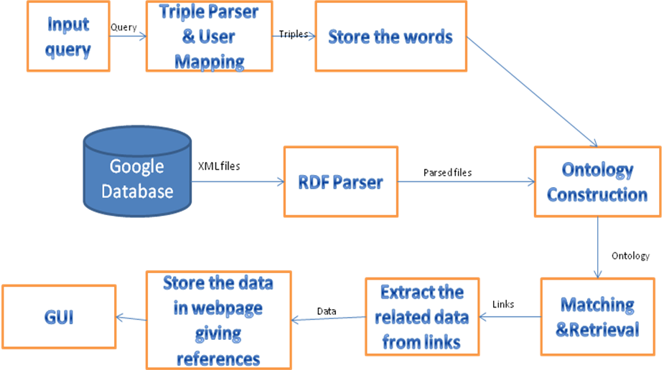
The figure gives the architecture diagram of our system. The details about each module are described below.
SEARCH INPUT QUERY: It is the keyword or the keywords entered by the user.
TRIPLE PARSER AND USER MAPPING & ONTOLOGY CONSTRUCTION: Here the user query is divided into triples through parser. This generated triple is used to match the triples which exist in the system. RDF is the standard for encoding metadata and other knowledge on the Semantic Web. The triples are already stored in the database which is retrieved from RDF files. The statement in RDF has 3 structural parts: a subject, a predicate and an object. These RDF files are fetched from the Internet. These RDF files are then parsed to form the RDF DOM. The Document Object Model (DOM) describes an RDF document as a tree-like structure, with every RDF element being a node in the tree. The DOM based parsed reads the entire document and forms corresponding document tree in memory. From the elements related terms are obtained and given to user to know the relevance of the words.
RETRIEVAL OF LINKS, EXTRACT THE RELATED DATA; STORE THE DATA IN A WEB-PAGE, GUI INTERFACE: From the obtained relevance of the terms with the original input the related links are extracted from the database. The content of these links are read and the data present are stored in a web-page giving the reference to the link from which the particular data was obtained. Finally, displaying the web page to the user with the help of a GU interface which helps in reduction of user’s efforts.
DATABASE is the collection of data records. For this system it will be storage for all the links available.
RDF PARSER: The RDF files gathered from the web are then sent to the RDF parser to convert the RDF files to triples i.e. resource, property and value

WORKING
The search query given by the user is divided into triples through parser. RDF is the standard for encoding metadata and other knowledge on the Semantic Web. The statement in RDF has 3 structural parts: a subject, a predicate and an object. These RDF files are created from XML files fetched from the Internet. These RDF files are then parsed to form the RDF DOM. The Document Object Model (DOM) describes an RDF document as a tree-like structure, with every RDF element being a node in the tree. The DOM based parser reads the entire document and forms corresponding document tree in memory. The triples are then created from the DOM structure and stored in database. These triples are compared with the triples generated from the query. The related data is taken from the matched documents and displayed to the user with respective links. Steps involved in this process:
Step 1. Create a triple parser to parse the input string/XML Parsing.
XML (EXTENSIBLE MARKUP LANGUAGE):
XML (Extensible Markup Language) is a set of rules for encoding documents electronically; XML’s design goals emphasize simplicity, generality and usability over the internet. It is the textual data format, with strong support via Unicode for the language of the world. It is widely used for representation of arbitrary data structures, for example web services.
XML Parsing
Parsing is the act of splitting up information into its component parts.
Example:
‘Mary feeds Spot’ parses as
Subject=Mary, proper noun
Predicate=feeds, present tense
Object=Spot, proper noun
A parser is a program which analyses files to identify the component parts (subject, predicate, and object). XML Parser reads the XML and identifies the function of each piece of the document, and it then makes that information available in memory to the rest of the program.
While reading an XML file, a parser checks the syntax for well-formed and reports any violations.
Example:
XML file:
<person corpid=”abc123” birth=”1990-11-23” gender=”female”>
<name>
<forename>abc</forename>
<surname>xyz</surname>
</name>
</person>
The above example parses as
Element person identified with Attribute corpid containing abc123 and Attribute birth containing 1990-11-23 and Attribute gender containing female containing
Element name containing
Element forename containing abc followed by
Element surname containing xyz

Step 2: Provide an interface to the user for a query to be entered.
Step 3: Construction of ontology or RDF DOM structure.
Step 4: Create a RDF parser to parse the obtained RDF files from the internet providing output as triples.

RDF (Resource Description Framework)

RDF is the standard for encoding metadata and other knowledge on the semantic web. In the semantic web, computer applications make use of structured information spread in a distributed and decentralized way throughout the current web. RDF is an abstract model, a way to break down knowledge into discrete pieces and while it is most popularly known for its RDF/ XML syntax, RDF can be stored in a variety of formats. The following discusses the abstract RDF model, two concrete serialization formats, how RDF is used and how it differs from plain XML, higher level RDF semantics, best practices for deployment and querying RDF data resources.
RDF is a standard model for data interchange on the web. RDF has features that facilitate data merging even if the underlying schemas differ and it specifically supports evolution of schemas over time without requiring all the data consumers to be changed.
RDF extends the linking structure of the web to use URI’s to name the relationship between things as well as the two ends of the link. (This is usually referred to as a triple).Using this simple model, it allows structure and semi-structured data to be mixed, exposed and shared across different applications.
This linking structure forms a directed, labeled graph where the edges represent the named link between two resources represented by the graph nodes. This graph view is the easiest possible mental model for RDF and is often used in easy to understand visual explanations.
BASIC RDF MODEL:
The foundation of RDF is a model for representing named properties and property values. The RDF model draws on well-established principles from various data representation communities. RDF properties maybe thought of as attributes of resources and in this sense correspond to traditional attribute- value pairs. RDF properties also represent relationships between resources and an RDF model can therefore resemble an entity – relationship diagram.
The basic data model consists of three object types:
Resources | All things being described by RDF expressions are called resources. A resource may be an entire Web page; such as the HTML document "http://www.w3.org/Overview.html" for example. A resource may be a part of a Web page; e.g. a specific HTML or XML element within the document source. A resource may also be a whole collection of pages; e.g. an entire Web site. A resource may also be an object that is not directly accessible via the Web; e.g. a printed book. Resources are always named by URIs plus optional anchor ids. Anything can have a URI; the extensibility of URIs allows the introduction of identifiers for any entity imaginable.
Properties | A property is a specific aspect, characteristic, attribute, or relation used to describe a resource. Each property has a specific meaning, defines its permitted values, the types of resources it can describe, and its relationship with other properties.
Statements | A specific resource together with a named property plus the value of that property for that resource is an RDF statement. These three individual parts of a statement are called, respectively, the subject, the predicate, and the object. The object of a statement (i.e., the property value) can be another resource or it can be a literal; i.e., a resource (specified by a URI) or a simple string or other primitive datatype defined by XML. In RDF terms, a literal may have content that is XML markup but is not further evaluated by the RDF processor.

Resources are identified by a “resource identifier”. A resource identifier is a URI plus an optional anchor id. For the purposes of this section, properties will be referred to by a simple name.
Consider as a simple example the sentence:
Ora Lassila is the creator of the resource http://www.w3.org/Home/Lassila.
This sentence has the following parts:
Subject (Resource) | http://www.w3.org/Home/Lassila
Predicate (Property) | Creator
Object (literal) | "Ora Lassila"

Step 5: A sub system to match the triples obtained from the user's input query and the obtained RDF files.
Step 6: An extractor to extract the data from the relevant links obtained after matching.
Step 7: A display window (interface) for the user to view the outputs of the extractor.
Thus with the above procedure and methodology helped with the description an Ontological Semantic Search Engine can be implemented with finesse.

Acknowledgment
The document would be incomplete without thanking the people of whose help made our idea be discussed so broadly and extensively. We thank Prof. Prakash Hegade, ISE Dept, BVBCET who has been the guiding light for us. We thank the other members of faculty of ISE Dept, BVBCET and all others who have directly or indirectly helped and co-operated with us in making this successful.

References

- Kyumars Sheyks Esmaili , Hassan Abolhassani, Mahmood Neshati, and Babak Bagheri Harir “MOSSE- A Multi Ontological Semantic Search Engine”, Sharif University Of Technology, Tehran, Iran,10.1.1.61.6192, 2006
- Debajyoti Mukhopadhyay,Aritra Banik.Sreemoyee Mukherjee,Jhilik Bhattacharya, ”A Domain Specific Ontology Based Semantic Web Search Engine ”, West Bengal University of Technology,Calcutta, arXiv:1102.0695v1,Feb 2011
- Georges Gardarin, Huaizhong KOU, Karine Zetourni, Xiaofeng Meng, Haiyan Wang,” SEWISE: An Ontology-based Web Information Search Engine.”, 2003
- Alexander Maedche and Raphael Volz,” The Ontology Extraction & Maintenance Framework Text-To-Onto”, 2009

